Casey Sheahan

8/24/2018

MLD Initial Portfolio and Opening Plan

Passion and interest and how to turn that into work had always been something I struggled with finding. I looked at them as two different sides of a road that would sometimes touch, but never completely merge. The stigma to work for a large corporation and receive the highest salary possible seemed to be the only factors students were taking into consideration when accepting offers. Even if these offers were in fields that they had no interest in. Like every other student, I also only considered salary and accepted a position in advertising sales. I never stopped to think if this was what I actually what I wanted to do. I was completely miserable for the next year of my life. However, that all changed when I had the opportunity to pursue a career in the field of higher education through a position at Georgetown University School of Medicine working for the Office of Student Affairs. My time at Georgetown confirmed every inkling I had at Georgia Tech that learning and higher education were my true interests and what I found reward in doing. If I would have taken the time during my undergraduate years to sit down and think about my passions and interests, I would have quickly realized that higher education is what fascinated me more than anything else. The Integrated Intro to the Field course created even more excitement about my future in education and the impact of what I can do.

The biggest fears I had coming into this program were that I knew I wanted to be in the field of higher education, but I had no idea what my place was or where I could even begin to make an impact. I wanted to discover my niche in the field that drove actual passion and excitement, while actually making an impact. I knew how big of a goal this was to tackle. I was afraid that this wasn’t possible or I would settle on an idea to meet requirements and push forward, but throughout the four days of class this nervous feeling started to shift to excitement and curiosity.

On day two of class, I was blown away by all of the student presentations. One particular piece of Emily Cotton’s that stuck out to me was her use of the website, Realtime Boards. I knew this would be a great way to begin the brainstorming process once I had an idea that I could move forward with. The first part of my idea came about when we broke into groups of three and were asked to explain our Program Pathway Prototypes to each other. Through that brainstorming session with the help of my peers, I came to this idea of students first finding interest and passion and building off that rather than picking something just because they excel at it or know it will make them successful.

When I look back at my undergraduate education, the piece that was really missing was the space and time to just think about your own career. It was so easy to get caught up with all of the school work and extracurricular activities and not have the time to stop to think about where you were headed. Once you picked your major, it was very difficult to change and the advice you would receive if you were considering changing paths was “Don’t worry no one ends up in the field they major in in College.” This really bothers me. Why don’t students spend more time developing their interests? Why can’t they take a class outside of their major if they are interested in it? Why do they have to pay for and take courses that they have no interest in? College students are paying thousands of dollars to be educated and learn information to take into the working world, but instead the only thing that seems to matter is the piece of paper you receive when you walk across the stage at graduation. I really believe that if students have the time and were taught to think differently about what they actually wanted to do this could change.

Our MLD cohort had the opportunity to listen to Professor Dutton speak about the idea of belonging and then participate in a group case study. The idea of belonging is particularly interesting to me especially because I was lucky enough to never have to face this issue. I entered college at the age of 17 and was pretty naïve. I was going to my first choice of universities and was overwhelming excited to start and meet new people. I quickly found friends during orientation and was lucky enough to have my older brother at Georgia Tech to learn on for support. As horrible as it sounds, I didn’t even consider how hard the transition can be for many students my first year. However, I did have the chance to work with students the next three years, as a Peer Leader, that were having difficulties. I worked with the Dean of Students to teach an introductory class to first semester freshman. All three years, we had students that really struggled with their first semester. One student had come over directly from Russia and was brilliant, but spoke little English and had a heavy smoking habit that was banned on campus. A decision to ban smoking that seemed so obvious to the administration made this student feel like a complete outsider for a habit that was extremely prevalent in his hometown. I wonder how he would have done if we could have found other students that were like him and could have empathized with the situation. I also wonder though if there was someone that might have not come from a similar background, but had a similar interest if this could have helped.

During the Case Study discussion with my group, I brought up the idea of pairing struggling students who feel like didn’t belong with other students that were not struggling with the transition. Many concerns were brought forward immediately and all of them were very valid. Some of them being that having the students’ help that were the reason the person felt like an outsider would make the situation worse. Another was that trying to create a friendship/relationship among young adults that don’t have a common ground is nearly impossible. I struggled with this for a bit because the idea that students in the same class at the same school could have such a negative effect on each other is difficult. It is reality though. I thought about our MLD cohort though. While we are older and much different than 18 year-olds going through one of their first large transitions in life, we all have such different backgrounds, but we all have the common ground of this program and general interest in Learning and Design. I know that belonging is a much deeper issue and there could be students in our cohort that don’t like they belong, but I think that our similar goals of career choice and passion make it a lot easier for us all to work together and understand each other. I am really interested to see if common interest is a start for a way to help improve belonging, not only similar background and beliefs.

As I sat down to write this paper and think about what I wanted to do, I had all of these largescale ideas running through my head. I went back to the website, Realtime Boards, finally having a better idea of what some of the issues in education I wanted to solve were. I still wasn’t sure how to connect them though. I first just listed what my personal interests and passions were and what drives me. (Appendix: Image A) and then looked for overarching themes of the three categories and came to five broad topics (Appendix: Image B). From these themes I put together the idea of “Connecting students through passion and differences to make an impact.” It’s an extremely broad idea, but one that I think combines a couple different challenges in education, my interests/passions and a lot of my excitement. So where to begin now? I haven’t decided if I first want to separately take a closer look into the different ideas to understand them better before. One being how interests and passions can help direct students through their undergraduate and graduate education and the second being how students with different backgrounds could help each other navigate their undergraduate years successfully.

Both separate ideas are so complicated that I hope to do more research throughout the semester to understand them better. I found a very interesting article on a website called Curiosity that was discussing the exact thought I had about passion and interest (<https://curiosity.com/topics/stop-trying-to-find-your-passion-say-stanford-researchers-do-this-instead-curiosity/)>. The article explains the potential problems with only following your passion and suggests to develop interests instead. There is a fascinating short video at the bottom of the article where John Marty, a youtuber, talks a little bit further about the idea of passion and how the book, *Grit,* dives into the make-up of passion citing it as interest and purpose. I already have this book ordered and am looking forward to reading more about the topic. I also having admitted how little I know about the issues with students not having a sense of belonging and what measures other universities have taken to try to address this issue will need to do much more research on it.

I am a bit unsure of how to develop this project into the next steps. I know some type of research study will have to be conducted and I would love the chance to work with some of the offices on campus that with all undergraduate students and some that specifically work with minorities. The School of Medicine uses Learning Societies, which are small groups of students formed to specifically be diverse, to create a sense of community immediately upon matriculation. I wonder if there is a way to design groups like these based off interests. Maybe also to give students a time or class where they are able to spend dedicated time to exploring their interests and options after graduation, where they could interact with students from different backgrounds. I am excited to move forward with the next step of developing this project.

**Appendix**

**Image 1**

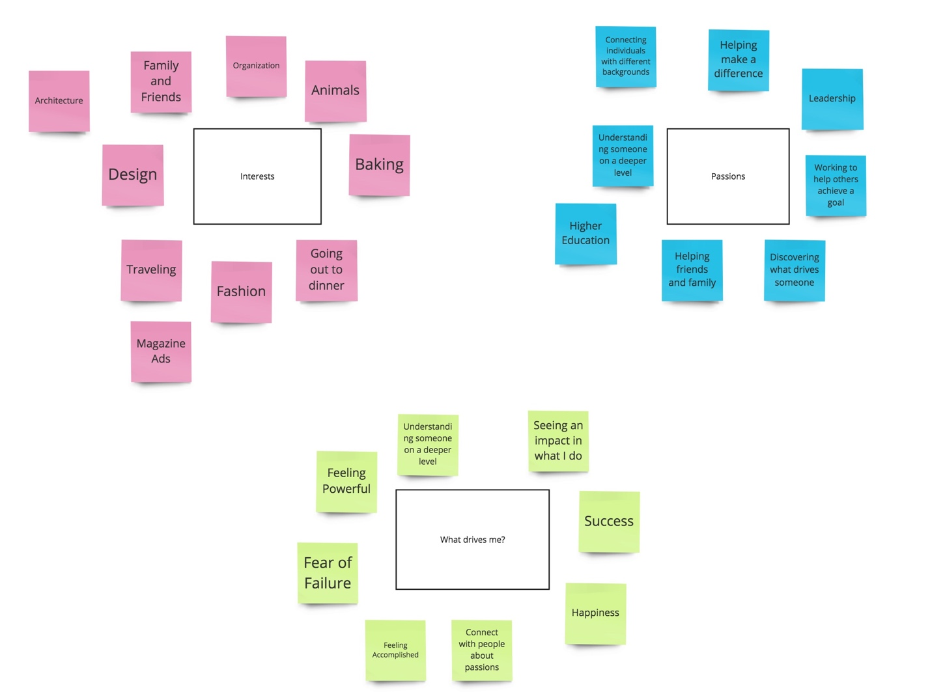

**Image B**

